Layout stuff

In ArcMap, rotate data frame to adjust ‘skewed’ appearance of map on page:

Data Frame -> Properties -> General (tab)-> Rotation (Adjust value until map looks horizontal)

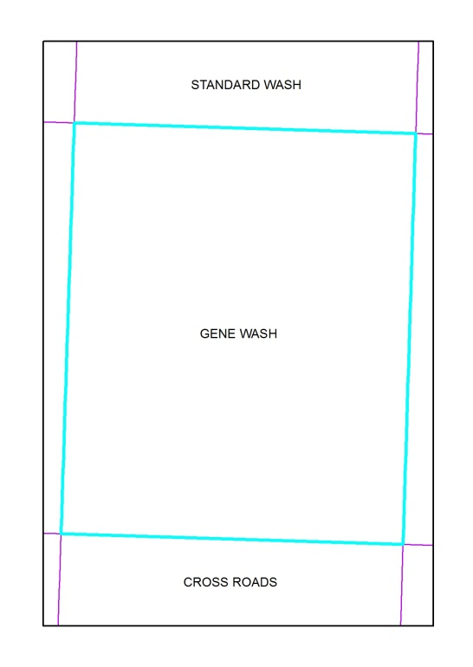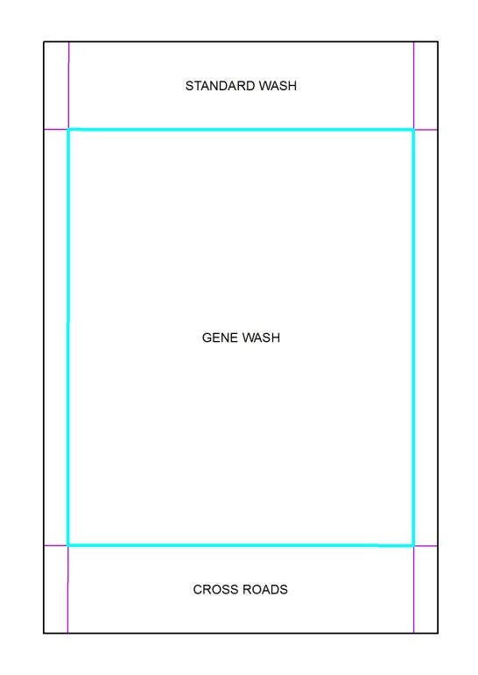

After Rotation

Before Rotation